# SEGRINATOR

##### **Sunil Kumar*, K Nazia*, Diksha*, Shivanshh\***

Department of Mechatronic Engineering, Chandigarh University

DOI: 25/NOV/2021



**UNIVERSITY INSTITUTE OF ENGINEERING**

**CHANDIGARH UNIVERSITY**

**GHARUAN, MOHALI, PUNJAB, INDIA-140413**

***Abstract*-The main objective of this project is to design a dustbin using Arduino, combined with both technology and hygiene in mind. This smart-bin management system is built on the microcontroller-based system having various sensors to separate the waste. The waste is separated into three categories – Metal waste is detected using an inductive proximity sensor which on metal detection drops the waste in the metal-based bin, similarly, wet and dry waste are separated using moisture detection as on detection drops waste in the wet based bin and when no moisture detected waste is dropped into the dry based bin.**

***Keywords*-Arduino, Servo Motors, Various Sensors, Waste Segregation.**

1. Introduction

Currently, garbage disposals have become quite problematic as segregating waste into various categories is also important. There are few who are knowledgeable in such related concepts but are quite lazy to do so, while there are also few who are clueless in such matters. With advancing technologies, the demand for smart homes is quite high, and as such the smart segregation concept comes to play an important role. Nobody wants to live in a messy or unhygienic place.

The garbage problem does not only lie in homes but also in the environment. We can hear some news regarding uncontrolled waste dumping on the corner of a neighbourhood, or it could be the garbage accumulated on the beaches. Though there is active environmentalist helping clean out such places the problem all the more stops at segregating, waste separation is an important concept that cannot be overlooked as some are bio-degradable while some aren’t, some can be recycled and some cannot. Leaving them unattended can be harmful which is toxic to the environment. It could also lead to health problems such as asthma, cancer, infectious disease, and many more.

1. Literature Review

|  |  |  |
| --- | --- | --- |
| Arduino UNO R3 is the heart of this project, it is an ATmega328P based microcontroller that includes all the components needed to hold a microcontroller, we attach it to PC using an USB cable, and using Arduino IDE, we can easily configure this program controller. | |  |
|  | Micro Servo Motor SG90 is a tiny and lightweight server motor with high output power. It can approximately rotate up to 180 degrees (90 in each direction), and works just like the standard kinds but smaller. | |
| MG995 Metal Gear Servo Motor is a high-speed standard servo rotating approximately 180 degrees (60 in each direction). It is a Digital Servo Motor which receives and processes PWM signal faster and better. | | Tower Pro MG995 Metal Gear Servo Motor (180 Degree Rotation) from ElectronicsComp.com |
| Tube Type Inductive Proximity Sensor Detection Switch NPN DC6-36V 4mm Normally Open switch LJ12A3-4-Z/BX | Robu.in | Inductive Proximity Sensors detects magnetic loss due to eddy currents that are generated on a conductive surface by an external magnetic field. On the detection coil, an AC magnetic field is generated, and changes in the impedance due to eddy currents generated on a metallic object are detected. | |
| A touch sensor is a device that captures and records physical touch or embrace on a device and/or object. It enables the device or object to detect touch or near proximity, typically by a human user or an operator. They are also called as tactile sensors and also, they are sensitive to touch, force or pressure. | | TTP223 - 1 Channel Capacitive Touch Sensor Module Blue Color from ElectronicsComp.com |

Components used:

* Arduino UNO R3
* Micro Servomotor
* Metal Servomotor
* Inductive Proximity Sensor
* Soil Moisture Sensor
* Touch Sensor
* IR Sensor
* Three Bins (to store waste)
* Jumper Wires
* Breadboard

Software used:

* Arduino IDE

Block Diagram:

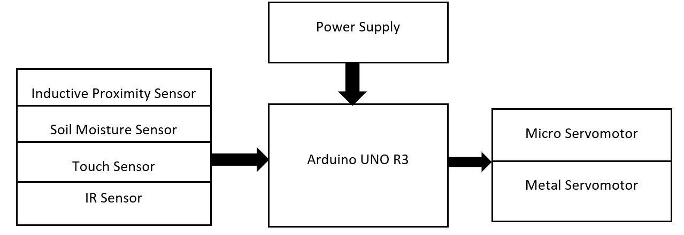

Design:

|  |
| --- |
| To create a smart dustbin, the structure was designed with easy access to rotation and less space to be occupied by the Segrinator.  Therefore, we have used wood as stand for strong support, the on the metal servo, we placed a plate to act as ground for the dustbins, the dustbin are placed between bolts for it to remain stable during the rotations. |
|  |

Circuit Diagram:

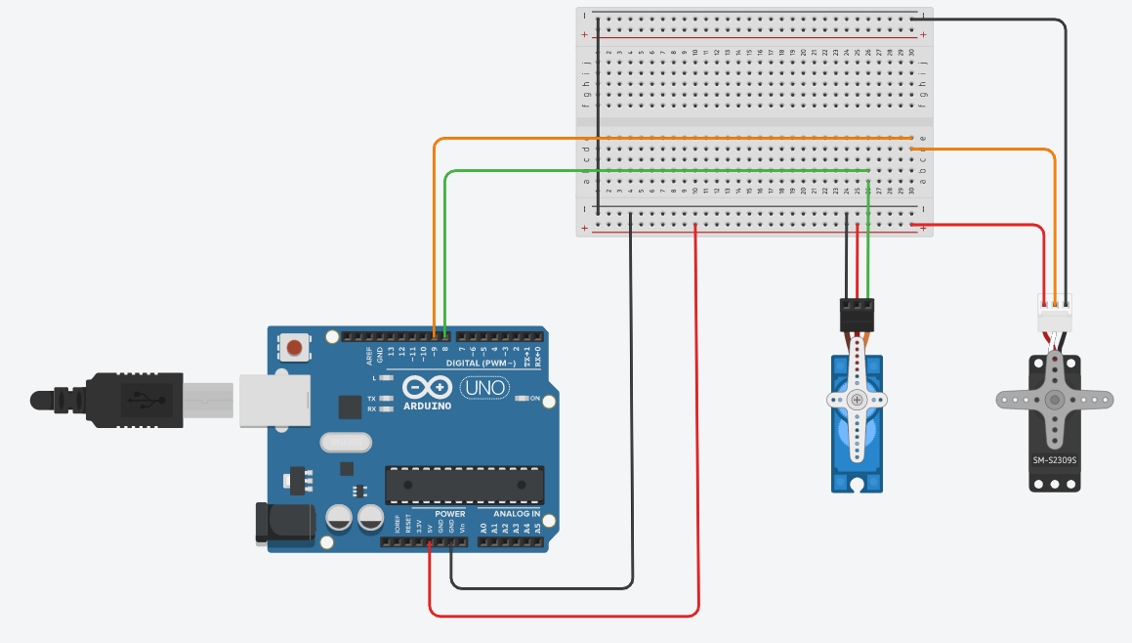

Fig.1.1

Arduino Uno is connected to two servo motors at digital pin 8 and 9. While at micro servomotor at digital pin 8 is the opening of the dustbin, the metal servomotor at digital pin 9 is used to rotate the position of bins to desired angle.

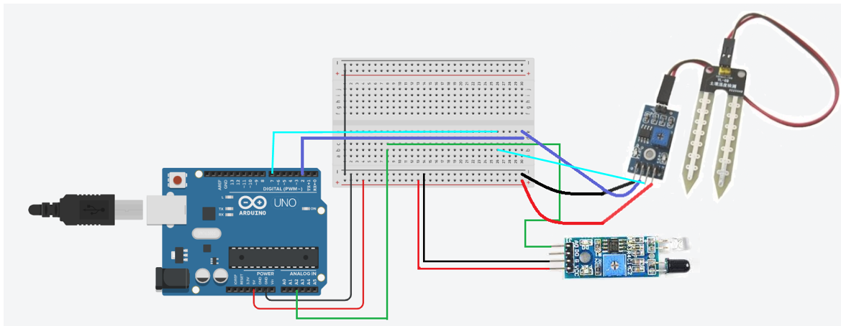

Fig.1.2

The IR Obstacle Avoidance Sensor is connected to analog pin A2 and the Soil moisture sensor module is connected to digital pin 2 and 7, while moisture input is at digital pin 2 and output at digital pin 7.

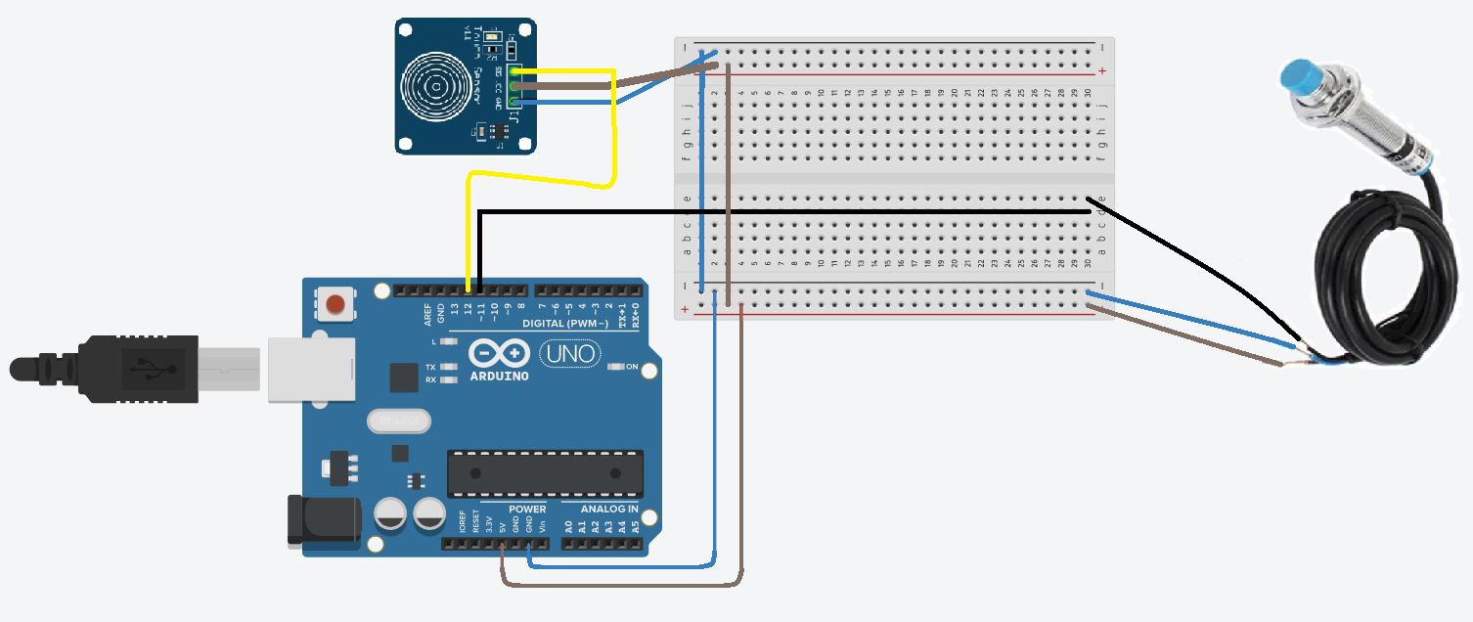

Fig.1.3

The touch sensor is connected at digital pin 12 and the inductive proximity sensor in is connected at digital pin 11.

|  |  |  |
| --- | --- | --- |
| Component Name | Arduino attached Pin No. |  |
| * Micro Servomotor | D8 |  |
| * Metal Servomotor | D9 |  |
| * Inductive Proximity Sensor | D11 |  |
| * Soil Moisture Sensor | D2 & D7 |  |
| * Touch Sensor | D12 |  |
| * IR Sensor | A2 | D- Digital A- Analog |

Process:

Arduino is programmed using Arduino IDE. A board is placed on top of a metal servomotor to which 3 bins are attached. Metal servo has three fixed positions: 0o for Dry Bin, 90o for Metal Bin, and 180o for Wet Bin. The micro servomotor is used as an opening to the Bin. When any waste is detected, the micro servo rotates to 90o else stays closed that is positioned at 0o.

Once the programme is uploaded the Arduino starts working.

Initially, Arduino defaults metal servomotor on which the bins are mounted to 90o. and micro servomotor to 0o.

Note: micro servo only rotates opens after metal servo has fixed to its desired position.

Firstly, metal detection is done using an inductive proximity sensor. Secondly, the moisture sensor detects if waste is wet or dry, the touch sensor also helps as an object identifier. For lightweight objects, we have used an IR sensor.

All the readings from each sensor are stored in a variable dedicated to each of them. Then the information is sent to the Arduino which then checks

* If metal is detected, metal servo stays at 90o and micro servo rotates open.
* If no metal but rather the moisture and touch sensor detect an object, the metal servo rotates 180o and the micro servo rotates open.
* And if no metal and no moisture is detected but the IR sensor still detects an object then metal servo rotates to 0o and micro servo rotates open.
* And when no object is detected then the micro servo remains closed

Since Arduino IDE keeps on running until the power supply is cut off. The above process keeps on repeating.

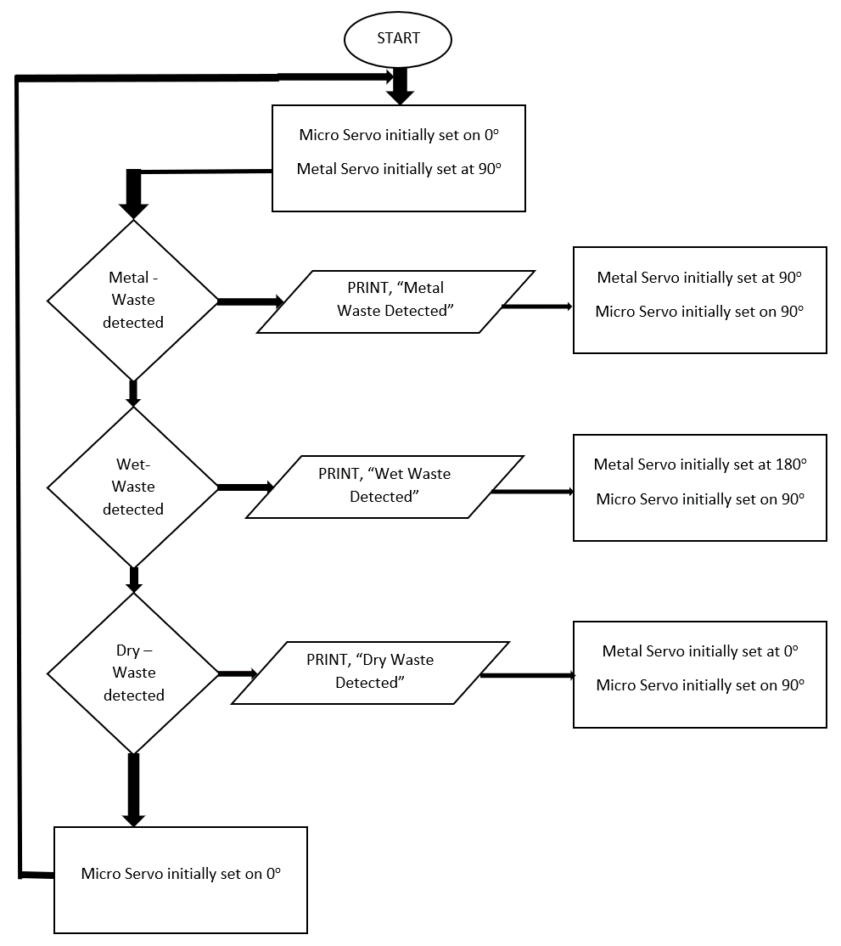

|  |  |  |  |
| --- | --- | --- | --- |
| **WASTE** | **Metal-Bin** | **Wet- Bin** | **Dry- Bin** |
| **Nail** | YES | - | - |
| **Wet tissue** | - | YES | - |
| **Paper** | - | - | YES |
| **pen** | YES | - | - |
| **Matchbox** | - | - | YES |

Application:

* Smart Segregation.
* Hygiene, safety and health benefits.
* Inexpensive and time saving in waste management.
* Easy to handle.
* Reduced waste and recycled waste
* Reduces environment pollution
* Reduced space consumption of landfills

1. RESULT

This is a smart-waste collector which uses various sensors that collects information, and transmits data to the microcontroller which then processes the collected data, and performs the necessary action or provides output to the servomotors.

1. CONCLUSION

The smart-segregator is very durable, time-efficient and easy to use. It helps with waste management by dividing waste into 3 categories: Dry, Wet & Metal which also helps with easy disposal of waste. Since the waste is efficiently separated and disposed of, the danger to toxins, or malaria or dengue or other harmful bacteria in the environment can be reduced significantly.

References

[1] P. R. No, ‘WASTE SEGREGATION USING SMART DUSTBIN PROJECT REFERENCE NO .: 40S _ BE _ 0621 Introduction : Objectives ’:

[2] I. P. Sensor, ‘AUTOMATIC WASTE SEGREGATOR PROJECT REFERENCE NO : 38S012 8’.

[3] ‘SENSOR BASED SMART DUSTBIN FOR WASTE SEGREGATION AND STATUS ALERT’, no. 5, pp. 98–103, 2017.

[4] N. S. Gupta, V. Deepthi, M. Kunnath, P. S. Rejeth, T. S. Badsha, and B. C. Nikhil, ‘Automatic Waste Segregation’, 2018 Second International Conference on Intelligent Computing and Control Systems (ICICCS), no. September 2020, pp. 1688–1692, 2018, doi: 10.1109/ICCONS.2018.8663148.

[5] G. Aahash, V. A. Prasath, D. Gopinath, M. G. Electronics, and C. Engineering, ‘Automatic Waste Segregator using Arduino’, vol. 6, no. 07, pp. 6–8, 2018.

[6] E. Malleswari and S. N. Kishore, ‘Smart Wastage Segregation using Arduino UNO’, no. 5, pp. 2074–2078, 2020, doi: 10.35940/ijrte.E5734.018520.

[7] ‘AUTOMATED WASTE SEGREGATION MACHINE’, vol. 8, no. 9, pp. 3068–3080, 2020.

[8] M. Pandey, A. Gowala, M. Goswami, and C. Saikia, ‘Smart dustbin using arduino’, no. August, 2020.

[9] C. Agarwal, ‘Automatic Waste Segregation and Management’, vol. 9, no. 06, pp. 715–718, 2020.

[10] J. Dileep, S. N. A. Ashitha, and S. N. Thoshitha, ‘Smart Waste Segregation using Arduino Uno’, vol. 8, no. 8, pp. 472–475, 2021, doi: 10.17148/IARJSET.2021.8878.

Authors

1. **First Author** –Sunil Kumar, 2nd year, B.E. Mechatronics’, uie.19bem1004@gmail.com
2. **Second Author** – K Nazia, 2nd year, B.E. Mechatronics’, uie.19bem1009@gmail.com
3. **Third Author** –Diksha, 2nd year, B.E. Mechatronics’, uie.19bem1026@gmail.com.
4. **Fourth Author** – Shivanshh, 2nd year, B.E. Mechatronics’, uie.19bem1051@gmail.com